CONSUMER

The Rise of the Chief Content Officer in Non-Media Companies

April 6, 2018

Today’s consumers crave authenticity. They expect their favorite brands to have independent opinions or personas that they respect and believe. Not surprisingly, in the past several years we’ve seen more than 50 leading non-media companies, including Capital One, Goldman Sachs, J. Crew, Microsoft and PepsiCo hire their first chief content officers (CCOs).1These new content creators are engaging with consumers in a way that is distinct from that of the chief marketing officer or chief communications officer.

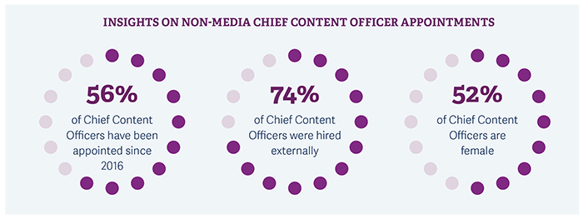

We’ve seen this role often in the past, but mostly in media organizations. Today, it’s gaining traction across other sectors and industries that see the need for independent, unbranded content that persuasively connects with consumers, earns their trust and reinforces core brand equity.

Why companies are hiring Chief Content Officers

As digital platforms such as Facebook, YouTube and Amazon engage the consumer more frequently and directly, the proliferation of consumer-facing content means that potential customers are increasingly skeptical. As a result, generating the right earned media response – online mentions, reposts, shares, reviews, recommendations or content picked up by third-party sites – has become more important, yet more challenging, than ever.

To meet this challenge, a growing number of companies are bringing in new content creators – whether they are CCOs, heads of content or editors-in-chief – who are generating everything from hard news articles to curated videos. Often former journalists, they are creating content that is relevant to their audiences, and they are primarily distributing it through owned media, keeping it independent from more traditional marketing messages.

As described by Angela Matusik, Head of Brand Journalism at HP, “This is not about steering people directly to purchase. It’s about creating long-term relationships with consumers.” And CCOs are being hired to do just that, creating a message that appeals to today’s consumers and giving the brand a clear and credible “point of view.”

How CCO content differs from marketing and communications

In today’s continuous whirlwind of unreliable social media posts, blogs and fake news, consumers crave a credibility that is not always possible to generate through traditional marketing tactics. They want a holistic relationship with their brands that allows for greater trust and connects them to an overarching message. From the perspective of Lou Ferrara, former Chief Content Officer of Bankrate, “You have to create a story, with expertise, that gains attention in a credible way. You’re trying to assert yourself as an authoritative, trusted source.” In contrast to the chief marketing officer – who drives critical strategies relating to competitive positioning, brand awareness, customer acquisition and, most of all, sales growth – the CCO exists to serve as the brand’s editor, producer or curator.

The type of content that a CCO may produce lives along a spectrum. But no matter where it sits on this spectrum – from a Bankrate news article such as Jobs Report Shows US Economy Added 200K jobs in January to a Red Bull adventure sports video series such as Away from the Keyboard – the brand, product and logo take a backseat.

We note that the relationship between marketing, communications and content is continuously evolving as the role of the CCO gains definition. Although chief content officers often report to the CEO, they may also report to the chief marketing officer or chief communications officer. If so, the CCO must clearly delineate the “separation of church and state” to ensure that content and marketing efforts are independent, yet aligned.

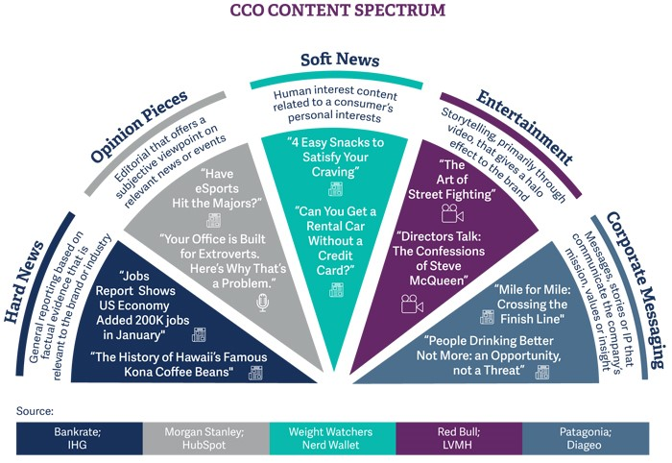

What is the role of the Chief Content Officer

The role of the CCO is still relatively new and companies are hiring them for a variety of reasons. Some are bringing in CCOs to build in-house production studios. Others want a CCO to take responsibility for corporate messaging. PepsiCo, for example, had a particular mandate to create content that would tell a story of sustainability, “leaving a positive imprint on society and the environment.” With that goal, the company hired Deborah Caldwell – a former managing editor at Time Inc. – to serve as the new Head of Content, where she says her general responsibility was to “enhance and protect PepsiCo’s reputation.”

Other companies are focused more specifically on the creation of hard news: building a news organization within the company to assert editorial integrity and become a credible source of relevant information. For example, CoStar, a commercial real estate information company, recently hired Dan Beyers, a former editor at the Washington Post, as its Vice President of News to build and lead a nationwide news organization that produces stories relevant to commercial real estate professionals.

Interestingly, since CCOs tend to be the lone content experts within an organization, they are frequently charged with defining the scope of their own roles as well as the broader content strategy, goals and organizational structure. As time goes on, however, we believe the responsibilities and KPIs of the CCO will become more clearly established.

Where to find your Chief Content Officer

We currently see CCOs coming primarily from three different backgrounds: journalism, marketing or communications, and other content-focused work.

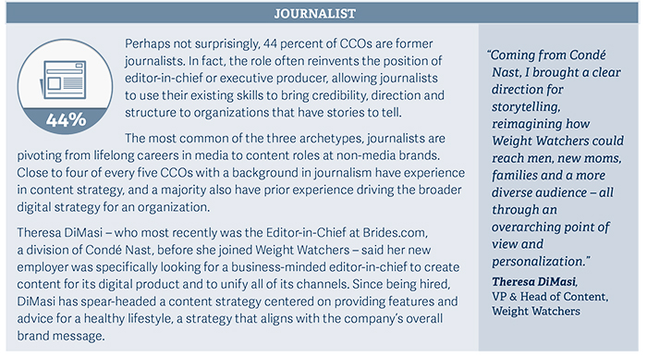

​​

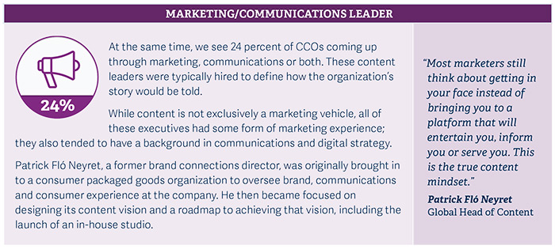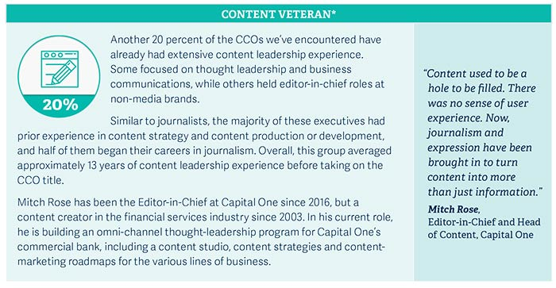

Are you ready for a Chief Content Officer?

To reach the increasingly skeptical consumer – overstimulated by social media and distrustful of online advertising – you need to produce a clear and credible message that communicates who your organization is, as a business and as a brand, and creates an authentic and relatable corporate persona. To do so, you’ll need to define your objectives, determine the essential messages or stories you wish to communicate, and then work to infuse your brand with credibility and character.

Deborah Caldwell, the former Head of Content at PepsiCo, predicts that, “very soon, everyone will consider at least a content strategy role – even if it’s not a chief content officer. Today, many companies still don’t have content to speak of. In 2018, that’s fine. But, eventually, it will become the norm to have content.” A growing number of consumer-facing companies are hiring a chief content officer to do just that. Is it time for your organization to hire one, too?

METHODOLOGY

Russell Reynolds Associates analyzed 50+ chief content officers at non-media companies to better understand the context behind the growth of the role. In addition, we held a series of in-depth interviews with 10 of these content leaders to gain more insights into the origin, purview and dynamics of the role.

AUTHORS

JESSICA WEBER is a member of Russell Reynolds Associates’ Consumer sector and a senior leader within the Digital Transformation and Retail practices. She co-leads the firm’s global Creative practice, which specializes in content, editorial anddesign roles. She is based in New York.

ALICESON ROBINSON is a member of the firm’s Consumer sector specializing in Media and Consumer Digital. She co-leads the firm’s global Creative practice and also advises cultural organizations as part of the Cultural Institutions and Foundations practice. She is based in London.

ADAM TWERSKY is a member of the firm’s Knowledge team for the Global Consumer sector, focusing on Retail, Consumer Digital & Media and Hospitality. He is based in Chicago.

SAMANTHA BERENBLUM is a member of the firm’s Knowledge team for the Global Consumer sector, focusing on Digital Media and Consumer Products. She is based in New York.

KRISTYNA JANSOVA is a member of the firm’s Knowledge team for the Global Consumer sector, focusing on Retail and Luxury. She is based in London.

FOOTNOTES:

*1For the purposes of this paper, we use “chief content officer” to describe this role, although there is significant variation in the exact titles granted.*

*\*These leaders encompass a broad group of industries and titles, including editor-in-chief, chief content officer, head of contentstrategy, head of thought leadership, and head of investment writing.*

​